Answers to the Exercises
1. Select significantly DEGs from the train dataset of AML (Acute Myelocytic Leukemia) and ALL (acute lymphoblastic leukemia) expression data (http://www.broadinstitute.org/cgi-bin/cancer/publications/pub_paper.cgi?mode=view&paper_id=43) and find enriched GO terms from an ontology analysis tool. Dataset and analysis functions are also included in R statistical package, golubEsets in Bioconductor.
2. List significantly enriched pathways using a pathway analysis tool with the dataset in Exercise 1
3. Find KEGG pathways significantly associated with leukemia subtype in the 2-sample comparison of AML and ALL by GSEA through the Kolmogorov-Smirnoff test. Analysis and data set are provided by SAFE R (http://bioconductor.org/packages/2.0/bioc/html/safe.html).
4. Identify the differentially co-expressed gene set pairs using dCoxS with simulated data in (http://www.snubi.org/publication/dCoxS). Compute interaction score between matrix M and M1 using ias fucntion. And, compute interaction score between M and M2. Finally, using compcorr function, estimate significance of difference of ias. Note that in compcorr function, n1 and n2 is the number of all possible sample pairs.
5. Report semantic relationships of pathways and GO terms using BioLattice (http://www.snubi.org/software/biolattice/). Use the result of k-means clustering (k=10) with DEG in Exercise 1. Select Category as ‘biological process’, p-value < 0.05.

Answer 1:
<DEG Gene List >
D87078_at (PUM2), D88270_at (VPREB1), J05243_at (SPTAN1), L41870_at (RB1), L47738_at (CYFIP2), M11147_at (FTL), M11722_at (DNTT), M16038_at (LYN), M21551_rna1_at (NMB), M23197_at (CD33), M27891_at (CST3), M29696_at (IL7R), M37435_at (CSF1), M55150_at (FAH), M60527_at (DCK), M62762_at (ATP6V0C), M89957_at (CD79B), M91432_at (ACADM), M94633_at (RAG2), S50223_at (ZNF22), U05259_rna1_at (CD79A), U20998_at (SRP9), U32944_at (DYNLL1), U46499_at (MGST1), U49844_at (ATR), U50136_rna1_at (LTC4S), U50928_at (PKD2), U62136_at (UBE2V2), U73737_at (MSH6), U82759_at (HOXA9), X04085_rna1_at (CAT), X15949_at (IRF2), X17042_at (SRGN), X59350_at (CD22), X61587_at (RHOG), X62535_at (DGKA), X62654_rna1_at (CD63), X63469_at (GTF2E2), X74262_at (RBBP4), X74801_at (CCT3), X82240_rna1_at (TCL1A), X95735_at (ZYX), Y12670_at (LEPROT), Z69881_at (ATP2A3), D38073_at (MCM3), U31556_at (E2F5), Z15115_at (TOP2B), U22376_cds2_s_at (MYB), L09209_s_at (APLP2), M12959_s_at (-), Y00787_s_at (IL8), M31211_s_at (MYL6B), U26266_s_at (DHPS), X85116_rna1_s_at (STOM), U49020_cds2_s_at (MEF2A), U72936_s_at (ATRX), J03801_f_at (LYZ), M19045_f_at (LYZ), M31523_at (TCF3), U27460_at (UGP2), U29175_at (SMARCA4)
* The significant genes were selected by t-test (p-value < 1.0e⁻⁵)
<Enriched GO terms>
TermID | Term | Count | % | PValue
GO:0002520 | immune system development | 8 | 12.5 | 1.88E-04
GO:0042113 | B cell activation | 5 | 7.8125 | 3.31E-04
GO:0030097 | hemopoiesis | 7 | 10.9375 | 5.50E-04
GO:0045321 | leukocyte activation | 7 | 10.9375 | 6.28E-04
GO:0048534 | hemopoietic or lymphoid organ development | 7 | 10.9375 | 9.14E-04
GO:0042100 | B cell proliferation | 3 | 4.6875 | 1.41E-03
GO:0006259 | DNA metabolic process | 9 | 14.0625 | 1.50E-03
GO:0001775 | cell activation | 7 | 10.9375 | 1.52E-03
GO:0002521 | leukocyte differentiation | 5 | 7.8125 | 2.53E-03
GO:0002377 | immunoglobulin production | 3 | 4.6875 | 7.52E-03
GO:0002440 | production of molecular mediator of immune response | 3 | 4.6875 | 8.02E-03

Answer 2:
KEGG04640: Hematopoietic cell lineage (pvalue = 1.9E-3)
KEGG05340: Primary immunodeficiency (pvalue = 1.9E -2)
KEGG04110: Cell cycle (pvalue = 1.9E-2)
KEGG04662: B cell receptor signaling pathway (pvalue = 1.9E-2)

Answer 3:
KEGGID | Size | Global.Stat | Emp.pvalue
KEGG00860 | 15 | 110.39778 | 0.003
KEGG04920 | 30 | 84.02642 | 0.011
KEGG04110 | 51 | 99.95088 | 0.012
KEGG00240 | 31 | 79.52313 | 0.022
KEGG00564 | 10 | 66.96118 | 0.03
KEGG00970 | 16 | 87.31489 | 0.03
KEGG04640 | 70 | 94.99477 | 0.032

Answer 4:
R code:
> re1 <- ias(M, M1)
> re2 <- ias(M, M2)
> n1 <- n2 <- ncol(M)*(ncol(M)-1)/2
> re <- compcorr(n1, re1[[1]], n2, re2[[2]])
The difference of IS between the two conditions is13.56 and p-value of the difference is 0.

Answer 5:

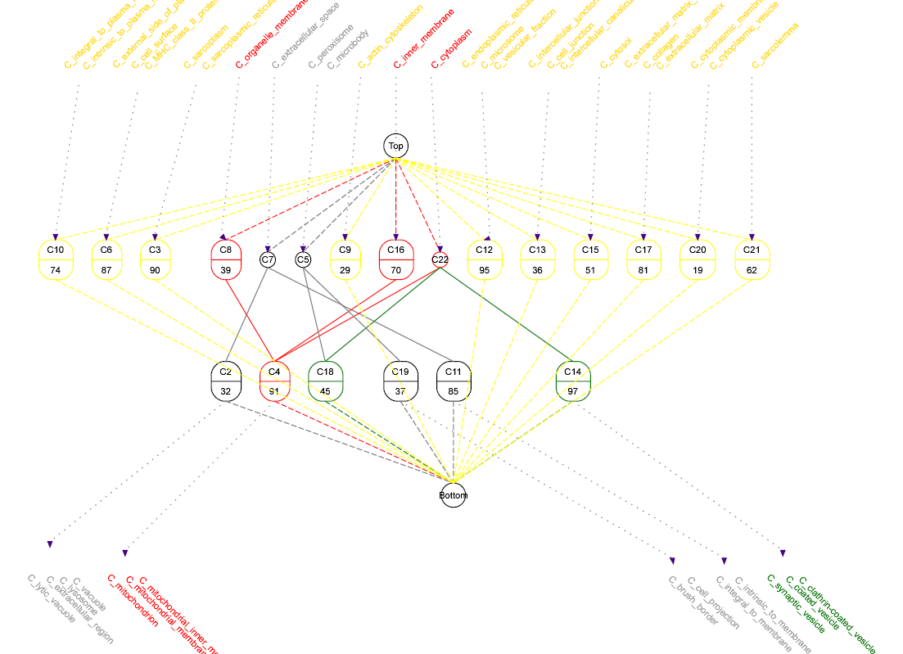

Order Table for concepts from experiment
Concept 6
cluster 87
C_external_side_of_plasma_membrane
C_cell_surface
C_MHC_class_II_protein_complex
Concept 21
cluster 62
C_sarcolemma
Concept 3
cluster 90
C_sarcoplasm
C_sarcoplasmic_reticulum
Concept 7  cluster 32,85  C_extracellular_space | Concept 2  cluster 32  C_lytic_vacuole  C_extracellular_region  C_lysosome  C_vacuole
Concept 11
cluster 85
C_integral_to_membrane
C_intrinsic_to_membrane
Concept 9
cluster 29
C_actin_cytoskeleton
Concept 17
cluster 81
C_extracellular_matrix_(sensu_Metazoa)
C_collagen
C_extracellular_matrix
Concept 12
cluster 95
C_endoplasmic_reticulum
C_microsome
C_vesicular_fraction
Concept 20
cluster 19
C_cytoplasmic_membrane-bound_vesicle
C_cytoplasmic_vesicle
Concept 15
cluster 51
C_cytosol
Concept 22  cluster 45,91,97  C_cytoplasm | Concept 4  cluster 91  C_mitochondrion  C_mitochondrial_membrane  C_mitochondrial_inner_membrane
Concept 14
cluster 97
C_synaptic_vesicle
C_coated_vesicle
C_clathrin-coated_vesicle
Concept 18
cluster 45
Concept 8  cluster 39,91  C_organelle_membrane | Concept 4  cluster 91  C_mitochondrion  C_mitochondrial_membrane  C_mitochondrial_inner_membrane
Concept 16  cluster 70,91  C_inner_membrane | Concept 4  cluster 91  C_mitochondrion  C_mitochondrial_membrane  C_mitochondrial_inner_membrane
Concept 10
cluster 74
C_integral_to_plasma_membrane
C_intrinsic_to_plasma_membrane
Concept 13
cluster 36
C_intercellular_junction
C_cell_junction
C_intercellular_canaliculus
Concept 5  cluster 37,45  C_peroxisome  C_microbody | Concept 18  cluster 45
Concept 19
cluster 37
C_brush_border
C_cell_projection

