Supporting Information – Text S1

Analysis of all human CO protein (n=5511) by GOrilla [Eden et al., 2007], shown for two-unranked test (1), and for lists ranked by RC (2) and RP (3).

1) Two-unranked test of 5511 human compositionally ordered proteins as target against the human proteome as background with p-value threshold of 10⁻⁶ yields:
Process
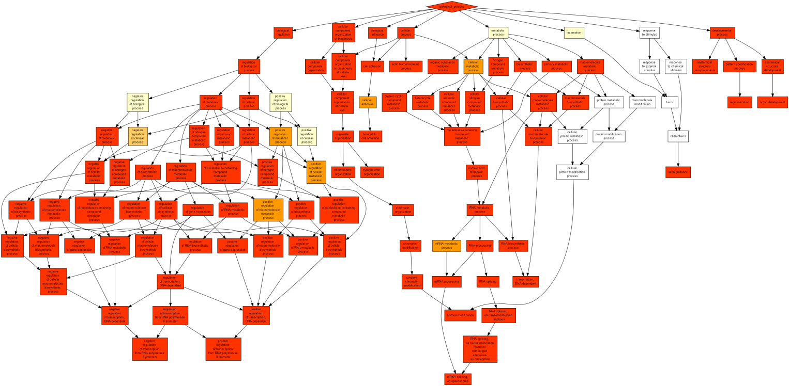
GO term | Description | P-value | FDR q-value | Enrichment (N, B, n, b)
GO:0006351 | transcription, DNA-dependent | 1.05E-153 | 1.17E-149 | 1.90 (17741,2116,5033,1140)
GO:0016070 | RNA metabolic process | 2.38E-140 | 1.32E-136 | 1.70 (17741,2951,5033,1423)
GO:0032774 | RNA biosynthetic process | 5.8E-140 | 2.14E-136 | 1.81 (17741,2308,5033,1187)
GO:0090304 | nucleic acid metabolic process | 1.06E-129 | 2.94E-126 | 1.61 (17741,3405,5033,1558)
GO:0051252 | regulation of RNA metabolic process | 3.39E-126 | 7.5E-123 | 1.68 (17741,2851,5033,1356)
GO:0006355 | regulation of transcription, DNA-dependent | 1.93E-122 | 3.56E-119 | 1.68 (17741,2771,5033,1319)
GO:0010468 | regulation of gene expression | 1.69E-121 | 2.67E-118 | 1.62 (17741,3207,5033,1470)
GO:0019219 | regulation of nucleobase-containing compound metabolic process | 4.72E-121 | 6.54E-118 | 1.61 (17741,3239,5033,1480)
GO:2001141 | regulation of RNA biosynthetic process | 1.76E-120 | 2.16E-117 | 1.67 (17741,2792,5033,1322)
GO:2000112 | regulation of cellular macromolecule biosynthetic process | 7.45E-118 | 8.24E-115 | 1.63 (17741,3008,5033,1392)
GO:0010556 | regulation of macromolecule biosynthetic process | 1.08E-114 | 1.09E-111 | 1.61 (17741,3070,5033,1406)
GO:0051171 | regulation of nitrogen compound metabolic process | 2.5E-114 | 2.3E-111 | 1.58 (17741,3319,5033,1491)
GO:0009059 | macromolecule biosynthetic process | 1.61E-108 | 1.37E-105 | 1.66 (17741,2606,5033,1228)
GO:0034645 | cellular macromolecule biosynthetic process | 1.63E-108 | 1.29E-105 | 1.66 (17741,2592,5033,1223)
GO:0031326 | regulation of cellular biosynthetic process | 6.55E-106 | 4.84E-103 | 1.57 (17741,3212,5033,1433)
GO:0009889 | regulation of biosynthetic process | 3.83E-104 | 2.65E-101 | 1.56 (17741,3240,5033,1438)
GO:0060255 | regulation of macromolecule metabolic process | 1.99E-94 | 1.29E-91 | 1.47 (17741,4013,5033,1669)
GO:0006139 | nucleobase-containing compound metabolic process | 1.98E-92 | 1.22E-89 | 1.47 (17741,3872,5033,1617)
GO:0031323 | regulation of cellular metabolic process | 5.9E-92 | 3.44E-89 | 1.44 (17741,4245,5033,1737)
GO:0080090 | regulation of primary metabolic process | 4.81E-88 | 2.66E-85 | 1.44 (17741,4158,5033,1697)
GO:0006725 | cellular aromatic compound metabolic process | 4.78E-82 | 2.52E-79 | 1.43 (17741,4030,5033,1637)
GO:0019222 | regulation of metabolic process | 1.91E-80 | 9.6E-78 | 1.39 (17741,4669,5033,1836)
GO:0046483 | heterocycle metabolic process | 2.42E-80 | 1.16E-77 | 1.43 (17741,4025,5033,1630)
GO:1901360 | organic cyclic compound metabolic process | 1.4E-72 | 6.48E-70 | 1.39 (17741,4207,5033,1663)
GO:0034641 | cellular nitrogen compound metabolic process | 1.22E-70 | 5.4E-68 | 1.39 (17741,4165,5033,1643)
GO:0006807 | nitrogen compound metabolic process | 5.36E-67 | 2.28E-64 | 1.38 (17741,4211,5033,1645)
GO:0044260 | cellular macromolecule metabolic process | 7.59E-63 | 3.11E-60 | 1.30 (17741,5443,5033,2013)
GO:0050794 | regulation of cellular process | 1.59E-59 | 6.29E-57 | 1.23 (17741,7499,5033,2611)
GO:0071704 | organic substance metabolic process | 3.63E-57 | 1.39E-54 | 1.33 (17741,4562,5033,1719)
GO:0050789 | regulation of biological process | 1.69E-51 | 6.25E-49 | 1.20 (17741,7922,5033,2698)
GO:0043170 | macromolecule metabolic process | 3.34E-50 | 1.19E-47 | 1.25 (17741,5951,5033,2114)
GO:0044249 | cellular biosynthetic process | 2.06E-49 | 7.14E-47 | 1.36 (17741,3546,5033,1368)
GO:0065007 | biological regulation | 5.04E-47 | 1.69E-44 | 1.18 (17741,8369,5033,2805)
GO:0009058 | biosynthetic process | 1.76E-42 | 5.72E-40 | 1.32 (17741,3704,5033,1390)
GO:0006357 | regulation of transcription from RNA polymerase II promoter | 1.17E-23 | 3.71E-21 | 1.48 (17741,1112,5033,466)
GO:0009987 | cellular process | 4.14E-22 | 1.27E-19 | 1.08 (17741,11975,5033,3665)
GO:0008380 | RNA splicing | 4.17E-22 | 1.25E-19 | 1.94 (17741,292,5033,161)
GO:0071842 | cellular component organization at cellular level | 1.6E-20 | 4.66E-18 | 1.27 (17741,2592,5033,935)
GO:0006397 | mRNA processing | 4.89E-20 | 1.39E-17 | 1.79 (17741,371,5033,188)
GO:0071841 | cellular component organization or biogenesis at cellular level | 4.92E-20 | 1.36E-17 | 1.27 (17741,2626,5033,943)
GO:0022610 | biological adhesion | 1.38E-19 | 3.71E-17 | 1.53 (17741,767,5033,332)
GO:0007155 | cell adhesion | 1.38E-19 | 3.63E-17 | 1.53 (17741,767,5033,332)
GO:0045893 | positive regulation of transcription, DNA-dependent | 2.21E-19 | 5.68E-17 | 1.46 (17741,962,5033,399)
GO:0006996 | organelle organization | 2.63E-19 | 6.61E-17 | 1.34 (17741,1681,5033,638)
GO:0051254 | positive regulation of RNA metabolic process | 9.58E-19 | 2.36E-16 | 1.44 (17741,1010,5033,413)
GO:0045934 | negative regulation of nucleobase-containing compound metabolic process | 1.98E-18 | 4.77E-16 | 1.48 (17741,853,5033,358)
GO:0032502 | developmental process | 4.02E-18 | 9.46E-16 | 1.21 (17741,3586,5033,1228)
GO:0051253 | negative regulation of RNA metabolic process | 4.55E-18 | 1.05E-15 | 1.50 (17741,776,5033,330)
GO:0051172 | negative regulation of nitrogen compound metabolic process | 4.99E-18 | 1.13E-15 | 1.47 (17741,863,5033,360)
GO:0010628 | positive regulation of gene expression | 1.61E-17 | 3.57E-15 | 1.42 (17741,1036,5033,417)
GO:0045892 | negative regulation of transcription, DNA-dependent | 2.01E-17 | 4.36E-15 | 1.50 (17741,748,5033,318)
GO:2000113 | negative regulation of cellular macromolecule biosynthetic process | 3.53E-17 | 7.51E-15 | 1.46 (17741,843,5033,350)
GO:0010558 | negative regulation of macromolecule biosynthetic process | 5.11E-17 | 1.07E-14 | 1.45 (17741,871,5033,359)
GO:0010557 | positive regulation of macromolecule biosynthetic process | 5.42E-17 | 1.11E-14 | 1.40 (17741,1099,5033,436)
GO:0045935 | positive regulation of nucleobase-containing compound metabolic process | 1.35E-16 | 2.72E-14 | 1.39 (17741,1125,5033,443)
GO:0010629 | negative regulation of gene expression | 1.94E-16 | 3.84E-14 | 1.46 (17741,819,5033,339)
GO:0051276 | chromosome organization | 2.84E-16 | 5.52E-14 | 1.53 (17741,611,5033,266)
GO:0051173 | positive regulation of nitrogen compound metabolic process | 3.87E-16 | 7.39E-14 | 1.38 (17741,1146,5033,448)
GO:0007010 | cytoskeleton organization | 4.41E-16 | 8.27E-14 | 1.54 (17741,593,5033,259)
GO:0048856 | anatomical structure development | 6.95E-16 | 1.28E-13 | 1.26 (17741,2150,5033,770)
GO:0045944 | positive regulation of transcription from RNA polymerase II promoter | 1.8E-15 | 3.27E-13 | 1.50 (17741,650,5033,277)
GO:0008150 | biological_process | 1.97E-15 | 3.52E-13 | 1.04 (17741,14369,5033,4259)
GO:0016043 | cellular component organization | 2.4E-15 | 4.21E-13 | 1.20 (17741,3188,5033,1088)
GO:0071840 | cellular component organization or biogenesis | 5.29E-15 | 9.15E-13 | 1.20 (17741,3222,5033,1096)
GO:0007156 | homophilic cell adhesion | 1.26E-14 | 2.15E-12 | 2.11 (17741,137,5033,82)
GO:0031327 | negative regulation of cellular biosynthetic process | 1.61E-14 | 2.7E-12 | 1.40 (17741,921,5033,366)
GO:0006396 | RNA processing | 2.11E-14 | 3.48E-12 | 1.50 (17741,612,5033,260)
GO:0016568 | chromatin modification | 2.82E-14 | 4.59E-12 | 1.64 (17741,381,5033,177)
GO:0009890 | negative regulation of biosynthetic process | 4.01E-14 | 6.44E-12 | 1.39 (17741,935,5033,369)
GO:0031328 | positive regulation of cellular biosynthetic process | 6.99E-14 | 1.11E-11 | 1.34 (17741,1208,5033,458)
GO:0009653 | anatomical structure morphogenesis | 9.45E-14 | 1.47E-11 | 1.35 (17741,1100,5033,422)
GO:0009891 | positive regulation of biosynthetic process | 1.64E-13 | 2.52E-11 | 1.33 (17741,1232,5033,464)
GO:0007389 | pattern specification process | 1.44E-12 | 2.19E-10 | 1.60 (17741,370,5033,168)
GO:0000122 | negative regulation of transcription from RNA polymerase II promoter | 1.98E-12 | 2.96E-10 | 1.54 (17741,452,5033,197)
GO:0010605 | negative regulation of macromolecule metabolic process | 8.35E-12 | 1.23E-9 | 1.30 (17741,1250,5033,461)
GO:0006325 | chromatin organization | 8.6E-11 | 1.25E-8 | 1.48 (17741,471,5033,198)
GO:0003002 | regionalization | 1.32E-10 | 1.9E-8 | 1.70 (17741,228,5033,110)
GO:0044238 | primary metabolic process | 1.37E-10 | 1.94E-8 | 1.09 (17741,7403,5033,2288)
GO:0016570 | histone modification | 1.99E-10 | 2.78E-8 | 1.71 (17741,216,5033,105)
GO:0016569 | covalent chromatin modification | 2.24E-10 | 3.1E-8 | 1.71 (17741,219,5033,106)
GO:0048513 | organ development | 2.72E-10 | 3.72E-8 | 1.34 (17741,855,5033,325)
GO:0031324 | negative regulation of cellular metabolic process | 2.73E-10 | 3.68E-8 | 1.28 (17741,1242,5033,450)
GO:0030029 | actin filament-based process | 2.86E-10 | 3.81E-8 | 1.56 (17741,337,5033,149)
GO:0009892 | negative regulation of metabolic process | 3.78E-10 | 4.98E-8 | 1.26 (17741,1339,5033,480)
GO:0000375 | RNA splicing, via transesterification reactions | 4.31E-10 | 5.61E-8 | 1.77 (17741,179,5033,90)
GO:0000377 | RNA splicing, via transesterification reactions with bulged adenosine as nucleophile | 5.68E-10 | 7.31E-8 | 1.78 (17741,172,5033,87)
GO:0000398 | mRNA splicing, via spliceosome | 5.68E-10 | 7.23E-8 | 1.78 (17741,172,5033,87)
GO:0007411 | axon guidance | 5.84E-10 | 7.34E-8 | 1.55 (17741,337,5033,148)

Function
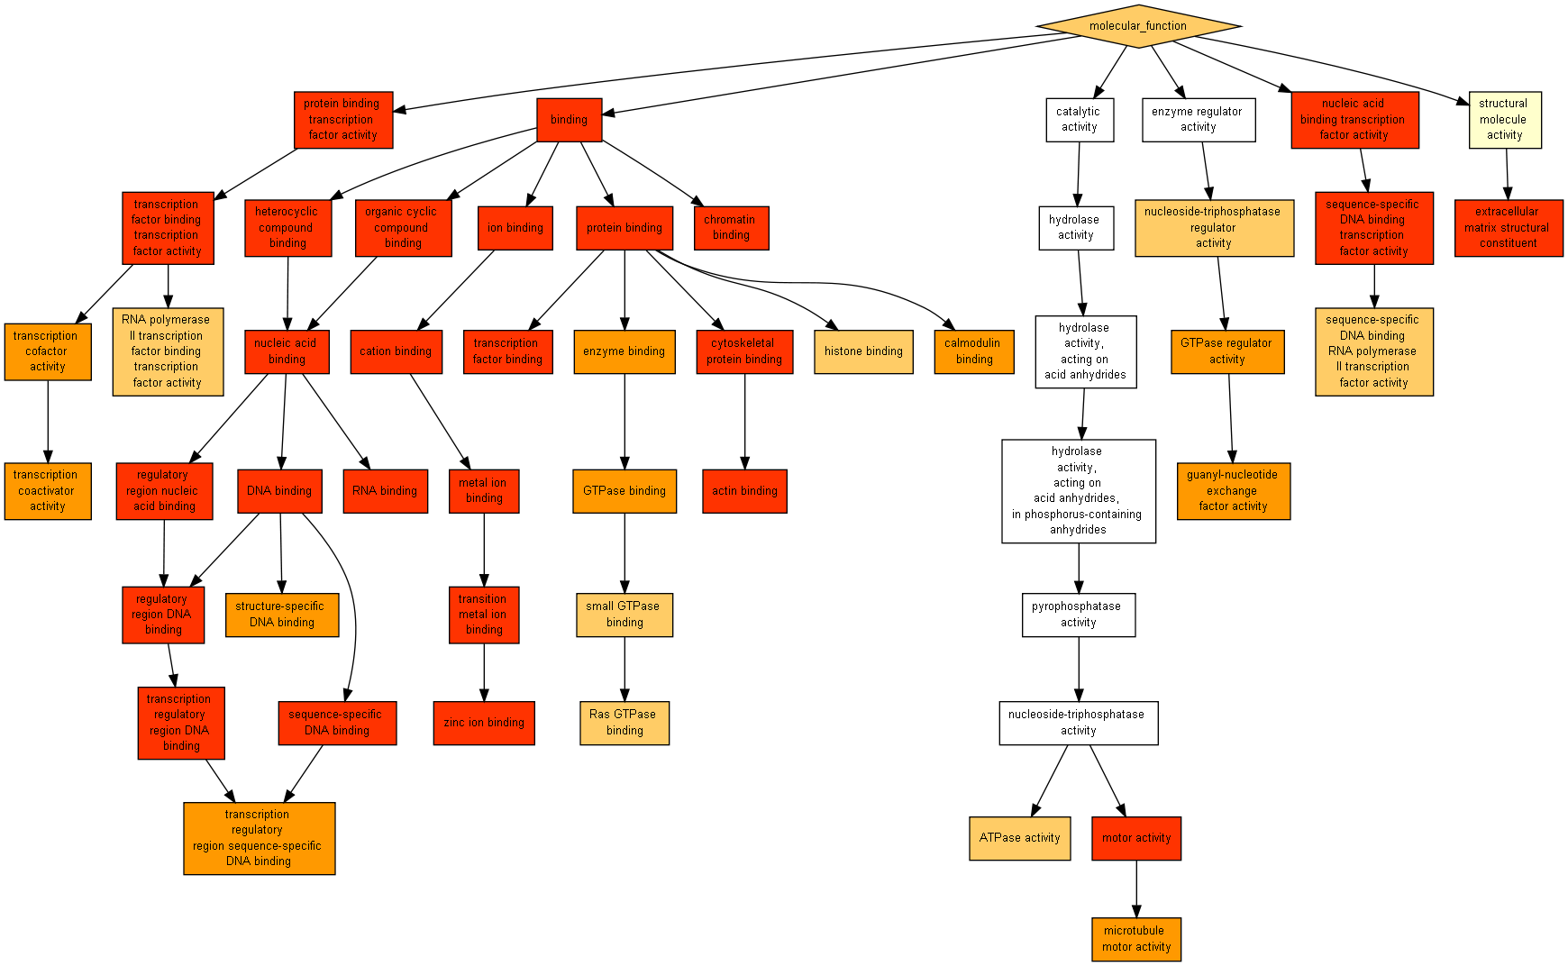
GO term | Description | P-value | FDR q-value | Enrichment (N, B, n, b)
GO:0003676 | nucleic acid binding | 1.5E-165 | 5.73E-162 | 1.71 (17741,3278,5033,1593)
GO:0003677 | DNA binding | 6.09E-155 | 1.16E-151 | 1.86 (17741,2316,5033,1219)
GO:0008270 | zinc ion binding | 3.48E-109 | 4.43E-106 | 1.78 (17741,1972,5033,998)
GO:0046914 | transition metal ion binding | 5.32E-91 | 5.09E-88 | 1.67 (17741,2206,5033,1043)
GO:1901363 | heterocyclic compound binding | 1.12E-89 | 8.54E-87 | 1.37 (17741,5294,5033,2062)
GO:0097159 | organic cyclic compound binding | 1.39E-89 | 8.87E-87 | 1.37 (17741,5295,5033,2062)
GO:0005488 | binding | 1.14E-77 | 6.2E-75 | 1.16 (17741,11726,5033,3846)
GO:0046872 | metal ion binding | 1.06E-58 | 5.06E-56 | 1.37 (17741,3887,5033,1512)
GO:0043169 | cation binding | 5.44E-55 | 2.31E-52 | 1.35 (17741,3959,5033,1521)
GO:0043167 | ion binding | 1.66E-54 | 6.34E-52 | 1.35 (17741,3968,5033,1522)
GO:0003700 | sequence-specific DNA binding transcription factor activity | 9.84E-34 | 3.42E-31 | 1.62 (17741,991,5033,455)
GO:0001071 | nucleic acid binding transcription factor activity | 1.78E-33 | 5.66E-31 | 1.62 (17741,993,5033,455)
GO:0008092 | cytoskeletal protein binding | 2.61E-23 | 7.67E-21 | 1.66 (17741,611,5033,287)
GO:0003779 | actin binding | 5.24E-22 | 1.43E-19 | 1.86 (17741,347,5033,183)
GO:0005515 | protein binding | 5.87E-21 | 1.5E-18 | 1.14 (17741,7059,5033,2278)
GO:0043565 | sequence-specific DNA binding | 3.69E-20 | 8.83E-18 | 1.58 (17741,669,5033,299)
GO:0044212 | transcription regulatory region DNA binding | 4.56E-17 | 1.03E-14 | 1.77 (17741,322,5033,162)
GO:0000975 | regulatory region DNA binding | 1.28E-16 | 2.72E-14 | 1.75 (17741,330,5033,164)
GO:0001067 | regulatory region nucleic acid binding | 1.28E-16 | 2.58E-14 | 1.75 (17741,330,5033,164)
GO:0003682 | chromatin binding | 4.98E-16 | 9.53E-14 | 1.85 (17741,254,5033,133)
GO:0003723 | RNA binding | 9.26E-15 | 1.69E-12 | 1.43 (17741,838,5033,339)
GO:0008134 | transcription factor binding | 4.57E-14 | 7.95E-12 | 1.62 (17741,399,5033,183)
GO:0003774 | motor activity | 9.91E-14 | 1.65E-11 | 2.10 (17741,129,5033,77)
GO:0005201 | extracellular matrix structural constituent | 1.14E-11 | 1.82E-9 | 2.30 (17741,78,5033,51)
GO:0000988 | protein binding transcription factor activity | 2.19E-10 | 3.36E-8 | 1.46 (17741,484,5033,201)
GO:0000989 | transcription factor binding transcription factor activity | 3.63E-10 | 5.34E-8 | 1.47 (17741,469,5033,195)
GO:0003712 | transcription cofactor activity | 1.65E-9 | 2.33E-7 | 1.46 (17741,453,5033,187)
GO:0019899 | enzyme binding | 4.23E-9 | 5.78E-7 | 1.28 (17741,1035,5033,377)
GO:0051020 | GTPase binding | 5.48E-9 | 7.22E-7 | 1.81 (17741,142,5033,73)
GO:0043566 | structure-specific DNA binding | 1.64E-8 | 2.09E-6 | 1.62 (17741,222,5033,102)
GO:0005085 | guanyl-nucleotide exchange factor activity | 2.81E-8 | 3.47E-6 | 1.72 (17741,162,5033,79)
GO:0003713 | transcription coactivator activity | 3.24E-8 | 3.87E-6 | 1.55 (17741,266,5033,117)
GO:0000976 | transcription regulatory region sequence-specific DNA binding | 4.83E-8 | 5.59E-6 | 1.76 (17741,140,5033,70)
GO:0005516 | calmodulin binding | 4.91E-8 | 5.52E-6 | 1.71 (17741,161,5033,78)
GO:0003777 | microtubule motor activity | 8.2E-8 | 8.96E-6 | 2.05 (17741,74,5033,43)
GO:0030695 | GTPase regulator activity | 8.25E-8 | 8.76E-6 | 1.42 (17741,423,5033,170)
GO:0016887 | ATPase activity | 2.73E-7 | 2.82E-5 | 1.44 (17741,347,5033,142)
GO:0031267 | small GTPase binding | 2.76E-7 | 2.78E-5 | 1.76 (17741,124,5033,62)
GO:0060589 | nucleoside-triphosphatase regulator activity | 3E-7 | 2.94E-5 | 1.39 (17741,436,5033,172)
GO:0000981 | sequence-specific DNA binding RNA polymerase II transcription factor activity | 3.18E-7 | 3.04E-5 | 1.54 (17741,233,5033,102)
GO:0001076 | RNA polymerase II transcription factor binding transcription factor activity | 3.31E-7 | 3.09E-5 | 1.93 (17741,84,5033,46)
GO:0042393 | histone binding | 3.37E-7 | 3.07E-5 | 1.83 (17741,104,5033,54)
GO:0017016 | Ras GTPase binding | 5.67E-7 | 5.04E-5 | 1.78 (17741,113,5033,57)

Component

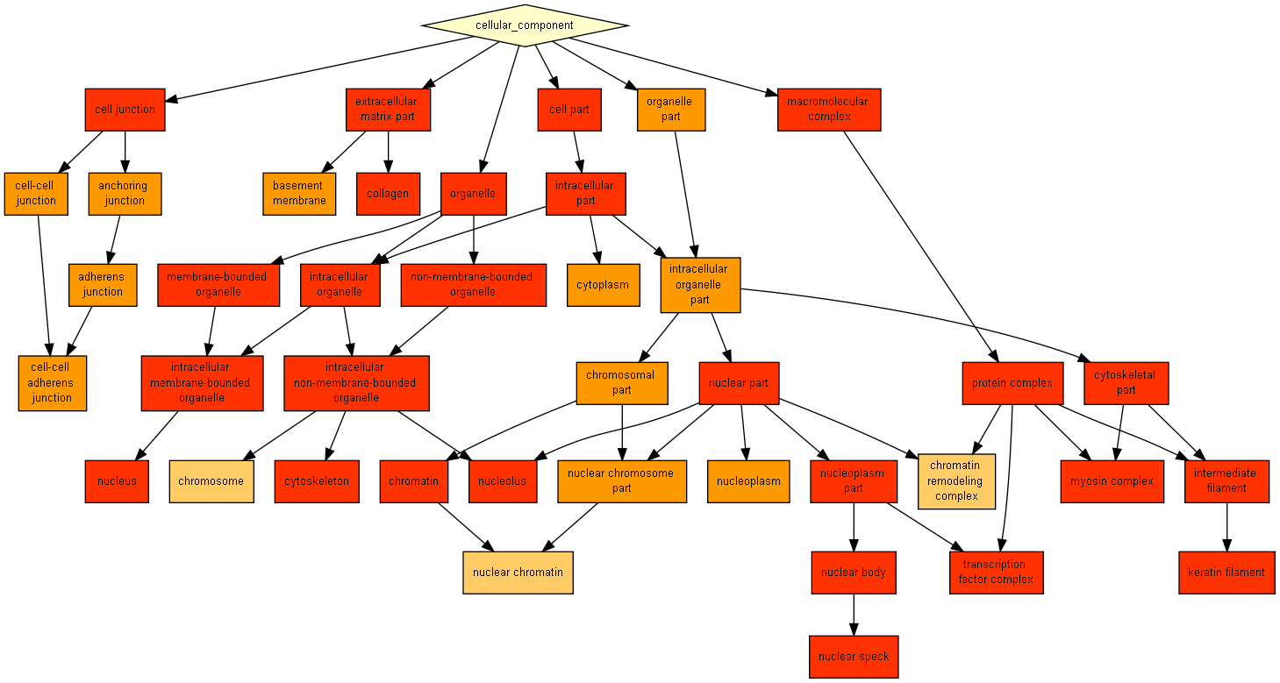
GO term | Description | P-value | FDR q-value | Enrichment (N, B, n, b)
GO:0005634 | nucleus | 1.36E-119 | 1.73E-116 | 1.47 (17741,4741,5033,1976)
GO:0043229 | intracellular organelle | 1.61E-65 | 1.03E-62 | 1.23 (17741,7999,5033,2780)
GO:0043226 | organelle | 2.67E-65 | 1.14E-62 | 1.22 (17741,8016,5033,2784)
GO:0044464 | cell part | 1.11E-49 | 3.54E-47 | 1.11 (17741,12594,5033,3968)
GO:0043231 | intracellular membrane-bounded organelle | 2.55E-48 | 6.52E-46 | 1.21 (17741,7072,5033,2437)
GO:0043227 | membrane-bounded organelle | 3.2E-48 | 6.83E-46 | 1.21 (17741,7077,5033,2438)
GO:0044424 | intracellular part | 8.92E-48 | 1.63E-45 | 1.12 (17741,12000,5033,3805)
GO:0044428 | nuclear part | 5.64E-43 | 9.01E-41 | 1.42 (17741,2428,5033,980)
GO:0044451 | nucleoplasm part | 2.89E-35 | 4.1E-33 | 1.72 (17741,793,5033,386)
GO:0044430 | cytoskeletal part | 5.07E-30 | 6.48E-28 | 1.51 (17741,1237,5033,531)
GO:0043228 | non-membrane-bounded organelle | 1.46E-25 | 1.7E-23 | 1.36 (17741,1932,5033,748)
GO:0043232 | intracellular non-membrane-bounded organelle | 1.46E-25 | 1.56E-23 | 1.36 (17741,1932,5033,748)
GO:0016604 | nuclear body | 4.65E-22 | 4.58E-20 | 1.99 (17741,268,5033,151)
GO:0045095 | keratin filament | 8.66E-22 | 7.91E-20 | 2.71 (17741,91,5033,70)
GO:0016607 | nuclear speck | 2.66E-20 | 2.26E-18 | 2.29 (17741,146,5033,95)
GO:0044420 | extracellular matrix part | 7.86E-20 | 6.27E-18 | 2.17 (17741,172,5033,106)
GO:0005581 | collagen | 1.38E-19 | 1.04E-17 | 2.64 (17741,88,5033,66)
GO:0005882 | intermediate filament | 8.04E-17 | 5.71E-15 | 2.03 (17741,184,5033,106)
GO:0043234 | protein complex | 5.15E-13 | 3.47E-11 | 1.18 (17741,3187,5033,1071)
GO:0032991 | macromolecular complex | 6.41E-13 | 4.1E-11 | 1.17 (17741,3756,5033,1242)
GO:0005856 | cytoskeleton | 4.84E-12 | 2.94E-10 | 1.43 (17741,655,5033,266)
GO:0005730 | nucleolus | 2E-11 | 1.16E-9 | 1.45 (17741,583,5033,239)
GO:0030054 | cell junction | 4.05E-10 | 2.25E-8 | 1.38 (17741,697,5033,272)
GO:0016459 | myosin complex | 6.3E-10 | 3.36E-8 | 2.31 (17741,64,5033,42)
GO:0005667 | transcription factor complex | 7.21E-10 | 3.69E-8 | 1.61 (17741,274,5033,125)
GO:0000785 | chromatin | 9.05E-10 | 4.45E-8 | 1.71 (17741,202,5033,98)
GO:0005737 | cytoplasm | 1.27E-9 | 5.99E-8 | 1.13 (17741,3929,5033,1265)
GO:0070161 | anchoring junction | 2.44E-9 | 1.11E-7 | 1.69 (17741,205,5033,98)
GO:0005911 | cell-cell junction | 4.41E-9 | 1.94E-7 | 1.59 (17741,264,5033,119)
GO:0044422 | organelle part | 6.63E-9 | 2.82E-7 | 1.09 (17741,6201,5033,1923)
GO:0005604 | basement membrane | 6.8E-9 | 2.8E-7 | 2.24 (17741,63,5033,40)
GO:0005912 | adherens junction | 9.89E-9 | 3.95E-7 | 1.69 (17741,188,5033,90)
GO:0044454 | nuclear chromosome part | 1.01E-8 | 3.93E-7 | 1.61 (17741,234,5033,107)
GO:0044427 | chromosomal part | 2.35E-8 | 8.82E-7 | 1.39 (17741,508,5033,201)
GO:0005913 | cell-cell adherens junction | 4.82E-8 | 1.76E-6 | 2.40 (17741,44,5033,30)
GO:0005654 | nucleoplasm | 6.34E-8 | 2.25E-6 | 1.28 (17741,925,5033,335)
GO:0044446 | intracellular organelle part | 8.6E-8 | 2.97E-6 | 1.09 (17741,6115,5033,1885)
GO:0000790 | nuclear chromatin | 1.76E-7 | 5.92E-6 | 1.83 (17741,110,5033,57)
GO:0016585 | chromatin remodeling complex | 2.22E-7 | 7.27E-6 | 1.76 (17741,126,5033,63)
GO:0005694 | chromosome | 2.95E-7 | 9.41E-6 | 1.74 (17741,132,5033,65)

2) RC - Ranked list test of 5511 human compositionally ordered proteins with p-value threshold of 10⁻⁶ yields:
Process
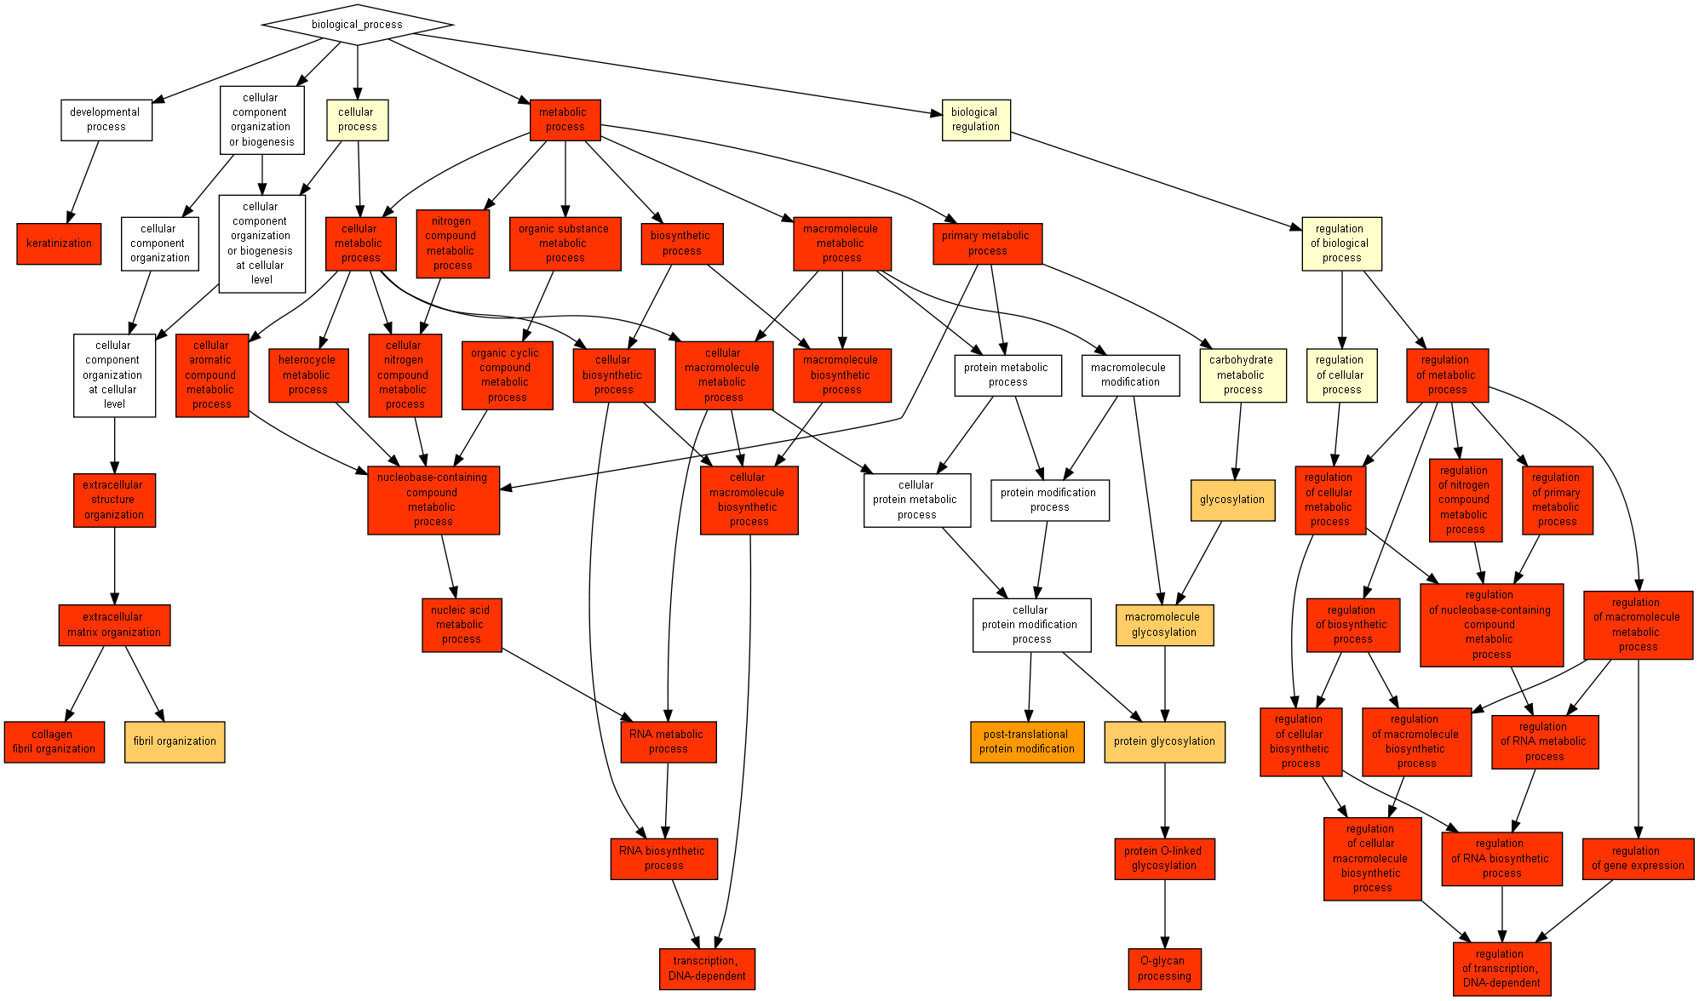
GO term | Description | P-value | FDR q-value | Enrichment (N, B, n, b)
GO:0006351 | transcription, DNA-dependent | 1.87E-56 | 1.39E-52 | 1.90 (5033,1140,991,427)
GO:0032774 | RNA biosynthetic process | 1.65E-54 | 6.1E-51 | 1.86 (5033,1187,991,435)
GO:0009059 | macromolecule biosynthetic process | 6.16E-53 | 1.52E-49 | 1.87 (5033,1228,924,421)
GO:0034645 | cellular macromolecule biosynthetic process | 5.31E-52 | 9.84E-49 | 1.82 (5033,1223,991,439)
GO:0016070 | RNA metabolic process | 6.54E-50 | 9.7E-47 | 1.72 (5033,1423,988,481)
GO:0090304 | nucleic acid metabolic process | 5.19E-43 | 6.41E-40 | 1.62 (5033,1558,996,500)
GO:0044249 | cellular biosynthetic process | 4.31E-42 | 4.57E-39 | 1.68 (5033,1368,991,453)
GO:0009058 | biosynthetic process | 9.55E-42 | 8.85E-39 | 1.80 (5033,1390,758,376)
GO:0051252 | regulation of RNA metabolic process | 4.34E-39 | 3.57E-36 | 1.68 (5033,1356,947,429)
GO:0046483 | heterocycle metabolic process | 4.95E-39 | 3.67E-36 | 1.57 (5033,1630,996,507)
GO:0006139 | nucleobase-containing compound metabolic process | 5.65E-39 | 3.8E-36 | 1.58 (5033,1617,996,504)
GO:0006725 | cellular aromatic compound metabolic process | 8.46E-39 | 5.23E-36 | 1.57 (5033,1637,996,508)
GO:0006355 | regulation of transcription, DNA-dependent | 2.81E-38 | 1.6E-35 | 1.69 (5033,1319,947,419)
GO:1901360 | organic cyclic compound metabolic process | 4.53E-38 | 2.4E-35 | 1.56 (5033,1663,996,512)
GO:2001141 | regulation of RNA biosynthetic process | 5.6E-38 | 2.77E-35 | 1.68 (5033,1322,947,419)
GO:0034641 | cellular nitrogen compound metabolic process | 8.27E-38 | 3.83E-35 | 1.56 (5033,1643,996,507)
GO:0006807 | nitrogen compound metabolic process | 1.27E-37 | 5.53E-35 | 1.56 (5033,1645,996,507)
GO:0071704 | organic substance metabolic process | 1E-36 | 4.12E-34 | 1.53 (5033,1719,996,521)
GO:2000112 | regulation of cellular macromolecule biosynthetic process | 7.81E-35 | 3.05E-32 | 1.61 (5033,1392,988,441)
GO:0010556 | regulation of macromolecule biosynthetic process | 1.63E-33 | 6.04E-31 | 1.60 (5033,1406,988,441)
GO:0010468 | regulation of gene expression | 5.94E-33 | 2.1E-30 | 1.57 (5033,1470,988,454)
GO:0031326 | regulation of cellular biosynthetic process | 2.74E-32 | 9.25E-30 | 1.59 (5033,1433,947,430)
GO:0009889 | regulation of biosynthetic process | 2.95E-32 | 9.52E-30 | 1.59 (5033,1438,947,431)
GO:0019219 | regulation of nucleobase-containing compound metabolic process | 3.02E-30 | 9.33E-28 | 1.56 (5033,1480,947,435)
GO:0051171 | regulation of nitrogen compound metabolic process | 2.5E-29 | 7.4E-27 | 1.55 (5033,1491,947,435)
GO:0044260 | cellular macromolecule metabolic process | 9.26E-28 | 2.64E-25 | 1.41 (5033,2013,996,560)
GO:0043170 | macromolecule metabolic process | 1.08E-23 | 2.96E-21 | 1.36 (5033,2114,996,569)
GO:0060255 | regulation of macromolecule metabolic process | 3.88E-23 | 1.03E-20 | 1.44 (5033,1669,988,471)
GO:0080090 | regulation of primary metabolic process | 8.15E-21 | 2.08E-18 | 1.42 (5033,1697,947,454)
GO:0031323 | regulation of cellular metabolic process | 1.48E-18 | 3.66E-16 | 1.39 (5033,1737,947,455)
GO:0044237 | cellular metabolic process | 2.97E-18 | 7.1E-16 | 1.30 (5033,2224,996,574)
GO:0030198 | extracellular matrix organization | 8.55E-18 | 1.98E-15 | 6.58 (5033,82,308,33)
GO:0043062 | extracellular structure organization | 1.36E-17 | 3.05E-15 | 6.50 (5033,83,308,33)
GO:0019222 | regulation of metabolic process | 2.1E-16 | 4.58E-14 | 1.43 (5033,1836,700,364)
GO:0044238 | primary metabolic process | 6.69E-15 | 1.42E-12 | 1.27 (5033,2288,996,575)
GO:0008152 | metabolic process | 5.62E-13 | 1.16E-10 | 1.24 (5033,2380,996,586)
GO:0016266 | O-glycan processing | 6.62E-13 | 1.33E-10 | 31.16 (5033,17,95,10)
GO:0006493 | protein O-linked glycosylation | 1.27E-11 | 2.48E-9 | 25.23 (5033,21,95,10)
GO:0031424 | keratinization | 2.28E-11 | 4.34E-9 | 4.28 (5033,26,994,22)
GO:0030199 | collagen fibril organization | 5.9E-10 | 1.09E-7 | 16.89 (5033,20,149,10)
GO:0043687 | post-translational protein modification | 5.75E-8 | 1.04E-5 | 12.32 (5033,43,95,10)
GO:0006486 | protein glycosylation | 3.57E-7 | 6.31E-5 | 10.39 (5033,51,95,10)
GO:0043413 | macromolecule glycosylation | 3.57E-7 | 6.16E-5 | 10.39 (5033,51,95,10)
GO:0070085 | glycosylation | 3.57E-7 | 6.02E-5 | 10.39 (5033,51,95,10)
GO:0043206 | fibril organization | 6.77E-7 | 1.12E-4 | 40.26 (5033,4,125,4)

Function
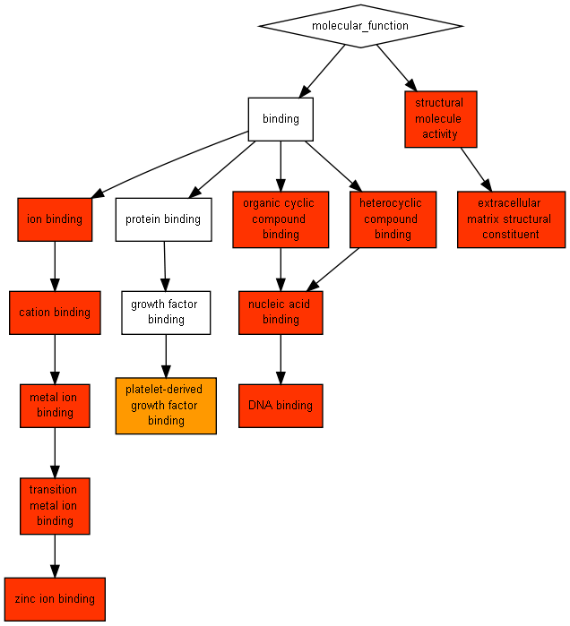
GO term | Description | P-value | FDR q-value | Enrichment (N, B, n, b)
GO:0008270 | zinc ion binding | 6.62E-68 | 1.21E-64 | 2.32 (5033,998,744,342)
GO:0046914 | transition metal ion binding | 5.77E-62 | 5.26E-59 | 2.22 (5033,1043,744,342)
GO:0003677 | DNA binding | 2.41E-50 | 1.46E-47 | 1.98 (5033,1219,743,356)
GO:0003676 | nucleic acid binding | 6.17E-50 | 2.81E-47 | 1.66 (5033,1593,992,521)
GO:0046872 | metal ion binding | 7.87E-40 | 2.87E-37 | 1.76 (5033,1512,705,373)
GO:0043169 | cation binding | 2.87E-39 | 8.72E-37 | 1.72 (5033,1521,753,392)
GO:0043167 | ion binding | 3.47E-39 | 9.04E-37 | 1.72 (5033,1522,753,392)
GO:0005201 | extracellular matrix structural constituent | 6.86E-26 | 1.56E-23 | 9.29 (5033,51,361,34)
GO:1901363 | heterocyclic compound binding | 7.33E-23 | 1.49E-20 | 1.36 (5033,2062,992,554)
GO:0097159 | organic cyclic compound binding | 7.33E-23 | 1.34E-20 | 1.36 (5033,2062,992,554)
GO:0005198 | structural molecule activity | 1.71E-15 | 2.84E-13 | 6.25 (5033,206,125,32)
GO:0048407 | platelet-derived growth factor binding | 2.81E-8 | 4.27E-6 | 30.20 (5033,8,125,6)

Component
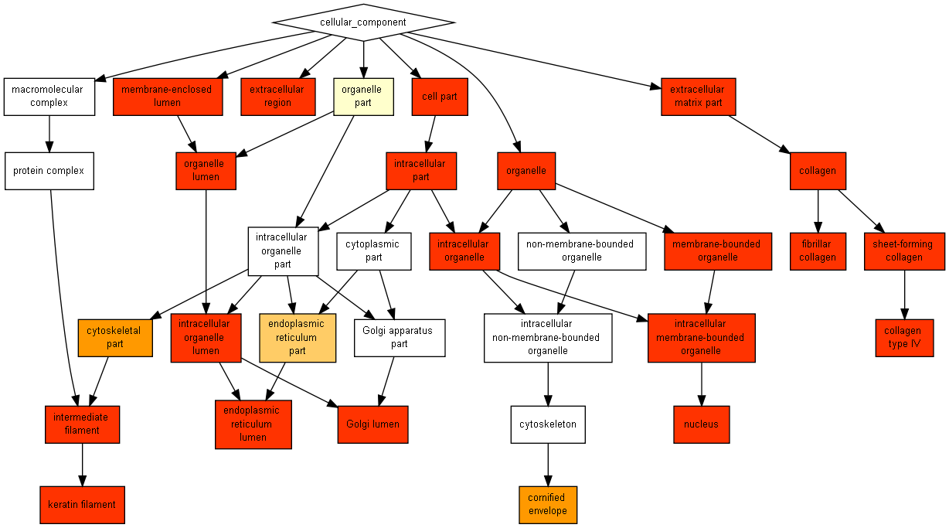
GO term | Description | P-value | FDR q-value | Enrichment (N, B, n, b)
GO:0005882 | intermediate filament | 1.36E-35 | 1.32E-32 | 5.32 (5033,106,607,68)
GO:0005634 | nucleus | 2.77E-33 | 1.34E-30 | 1.45 (5033,1976,996,567)
GO:0045095 | keratin filament | 4.93E-30 | 1.6E-27 | 6.62 (5033,70,521,48)
GO:0044424 | intracellular part | 1.42E-29 | 3.44E-27 | 1.18 (5033,3805,996,889)
GO:0044464 | cell part | 7.16E-25 | 1.39E-22 | 1.15 (5033,3968,996,904)
GO:0070013 | intracellular organelle lumen | 5.9E-24 | 9.55E-22 | 6.39 (5033,115,308,45)
GO:0043233 | organelle lumen | 5.91E-21 | 8.19E-19 | 5.57 (5033,132,308,45)
GO:0031974 | membrane-enclosed lumen | 1.75E-20 | 2.13E-18 | 5.45 (5033,135,308,45)
GO:0005581 | collagen | 3.44E-19 | 3.71E-17 | 7.68 (5033,66,308,31)
GO:0005788 | endoplasmic reticulum lumen | 2.85E-18 | 2.77E-16 | 7.54 (5033,65,308,30)
GO:0043231 | intracellular membrane-bounded organelle | 1.14E-17 | 1E-15 | 1.27 (5033,2437,999,616)
GO:0043227 | membrane-bounded organelle | 1.3E-17 | 1.05E-15 | 1.27 (5033,2438,999,616)
GO:0043229 | intracellular organelle | 5.09E-17 | 3.8E-15 | 1.23 (5033,2780,992,676)
GO:0043226 | organelle | 8.5E-17 | 5.9E-15 | 1.23 (5033,2784,992,676)
GO:0044420 | extracellular matrix part | 9.19E-16 | 5.95E-14 | 5.28 (5033,106,324,36)
GO:0005583 | fibrillar collagen | 1.91E-14 | 1.16E-12 | 30.71 (5033,11,149,10)
GO:0005576 | extracellular region | 3.32E-12 | 1.9E-10 | 4.31 (5033,301,128,33)
GO:0005587 | collagen type IV | 4.42E-11 | 2.38E-9 | 59.92 (5033,6,84,6)
GO:0030935 | sheet-forming collagen | 1.08E-10 | 5.52E-9 | 30.88 (5033,7,163,7)
GO:0005796 | Golgi lumen | 7.02E-10 | 3.41E-8 | 18.27 (5033,29,95,10)
GO:0044430 | cytoskeletal part | 2.02E-8 | 9.35E-7 | 2.59 (5033,531,161,44)
GO:0001533 | cornified envelope | 7.5E-8 | 3.31E-6 | 5.00 (5033,15,873,13)
GO:0044432 | endoplasmic reticulum part | 2.79E-7 | 1.18E-5 | 3.50 (5033,208,173,25)

3) RP - Ranked list test of 5511 human compositionally ordered proteins, with p-value threshold of 10⁻⁶ yields:
Process
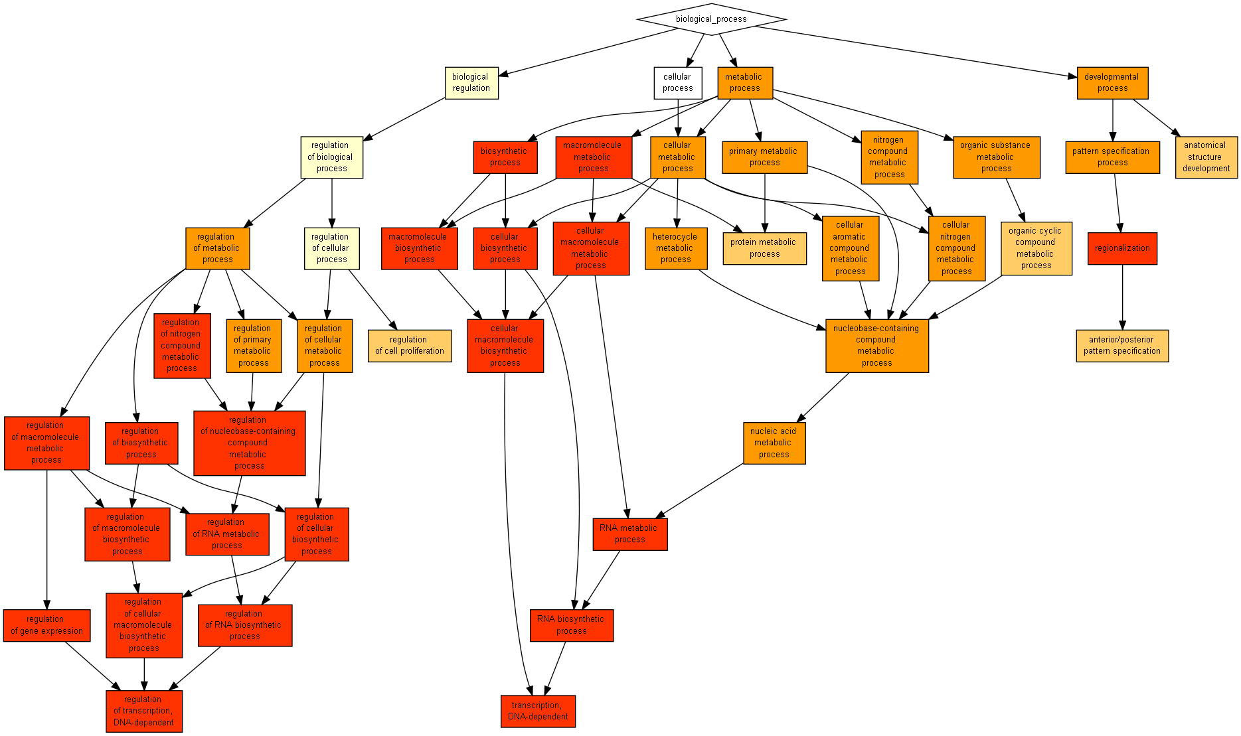
GO term | Description | P-value | FDR q-value | Enrichment (N, B, n, b)
GO:0032774 | RNA biosynthetic process | 3.01E-14 | 2.23E-10 | 1.47 (5033,1187,897,312)
GO:0006351 | transcription, DNA-dependent | 1.52E-13 | 5.64E-10 | 1.48 (5033,1140,897,300)
GO:0009058 | biosynthetic process | 2.42E-13 | 5.99E-10 | 1.39 (5033,1390,897,344)
GO:0051252 | regulation of RNA metabolic process | 5.11E-13 | 9.47E-10 | 1.39 (5033,1356,900,337)
GO:0034645 | cellular macromolecule biosynthetic process | 5.7E-13 | 8.46E-10 | 1.45 (5033,1223,897,315)
GO:0006355 | regulation of transcription, DNA-dependent | 7.57E-13 | 9.35E-10 | 1.39 (5033,1319,900,329)
GO:2001141 | regulation of RNA biosynthetic process | 1.07E-12 | 1.13E-9 | 1.39 (5033,1322,900,329)
GO:0009059 | macromolecule biosynthetic process | 1.11E-12 | 1.03E-9 | 1.44 (5033,1228,897,315)
GO:0044249 | cellular biosynthetic process | 1.19E-12 | 9.77E-10 | 1.41 (5033,1368,897,343)
GO:0031326 | regulation of cellular biosynthetic process | 1.04E-11 | 7.68E-9 | 1.35 (5033,1433,900,347)
GO:0043170 | macromolecule metabolic process | 1.43E-11 | 9.62E-9 | 1.26 (5033,2114,897,474)
GO:0009889 | regulation of biosynthetic process | 1.8E-11 | 1.11E-8 | 1.35 (5033,1438,900,347)
GO:0010556 | regulation of macromolecule biosynthetic process | 2.78E-11 | 1.59E-8 | 1.35 (5033,1406,900,340)
GO:2000112 | regulation of cellular macromolecule biosynthetic process | 3.06E-11 | 1.62E-8 | 1.35 (5033,1392,900,337)
GO:0016070 | RNA metabolic process | 3.37E-11 | 1.66E-8 | 1.35 (5033,1423,897,342)
GO:0010468 | regulation of gene expression | 3.52E-11 | 1.63E-8 | 1.34 (5033,1470,900,352)
GO:0019219 | regulation of nucleobase-containing compound metabolic process | 6.01E-11 | 2.62E-8 | 1.33 (5033,1480,900,353)
GO:0051171 | regulation of nitrogen compound metabolic process | 1.83E-10 | 7.54E-8 | 1.32 (5033,1491,900,353)
GO:0060255 | regulation of macromolecule metabolic process | 3.27E-10 | 1.28E-7 | 1.29 (5033,1669,897,385)
GO:0003002 | regionalization | 6.16E-10 | 2.28E-7 | 3.48 (5033,110,447,34)
GO:0044260 | cellular macromolecule metabolic process | 6.22E-10 | 2.19E-7 | 1.25 (5033,2013,897,448)
GO:0044238 | primary metabolic process | 1.08E-9 | 3.64E-7 | 1.22 (5033,2288,897,497)
GO:0090304 | nucleic acid metabolic process | 3.69E-9 | 1.19E-6 | 1.29 (5033,1558,897,359)
GO:0080090 | regulation of primary metabolic process | 7.33E-9 | 2.26E-6 | 1.27 (5033,1697,897,384)
GO:0032502 | developmental process | 7.97E-9 | 2.36E-6 | 1.54 (5033,1228,412,155)
GO:0031323 | regulation of cellular metabolic process | 1.46E-8 | 4.17E-6 | 1.26 (5033,1737,897,390)
GO:0007389 | pattern specification process | 2.1E-8 | 5.78E-6 | 2.75 (5033,168,447,41)
GO:0008152 | metabolic process | 2.17E-8 | 5.75E-6 | 1.20 (5033,2380,897,507)
GO:0034641 | cellular nitrogen compound metabolic process | 2.71E-8 | 6.92E-6 | 1.27 (5033,1643,897,371)
GO:0019222 | regulation of metabolic process | 2.95E-8 | 7.28E-6 | 1.24 (5033,1836,897,407)
GO:0006807 | nitrogen compound metabolic process | 3.13E-8 | 7.48E-6 | 1.27 (5033,1645,897,371)
GO:0071704 | organic substance metabolic process | 3.17E-8 | 7.35E-6 | 1.26 (5033,1719,897,385)
GO:0006139 | nucleobase-containing compound metabolic process | 4.34E-8 | 9.76E-6 | 1.27 (5033,1617,897,365)
GO:0044237 | cellular metabolic process | 5.04E-8 | 1.1E-5 | 1.20 (5033,2224,897,477)
GO:0006725 | cellular aromatic compound metabolic process | 6.13E-8 | 1.3E-5 | 1.26 (5033,1637,897,368)
GO:0046483 | heterocycle metabolic process | 8.38E-8 | 1.72E-5 | 1.26 (5033,1630,897,366)
GO:1901360 | organic cyclic compound metabolic process | 1.44E-7 | 2.89E-5 | 1.25 (5033,1663,897,371)
GO:0048856 | anatomical structure development | 4.36E-7 | 8.5E-5 | 1.64 (5033,770,426,107)
GO:0019538 | protein metabolic process | 5.5E-7 | 1.05E-4 | 1.79 (5033,713,319,81)
GO:0042127 | regulation of cell proliferation | 6.8E-7 | 1.26E-4 | 1.92 (5033,298,581,66)
GO:0009952 | anterior/posterior pattern specification | 8.16E-7 | 1.48E-4 | 3.59 (5033,69,447,22)

Function
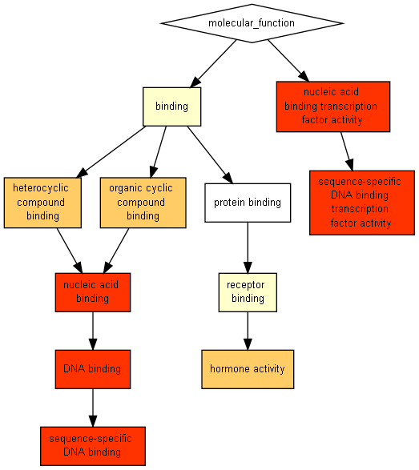
GO term | Description | P-value | FDR q-value | Enrichment (N, B, n, b)
GO:0003676 | nucleic acid binding | 3.97E-15 | 7.24E-12 | 1.39 (5033,1593,897,396)
GO:0003677 | DNA binding | 5.44E-15 | 4.96E-12 | 1.48 (5033,1219,897,321)
GO:0043565 | sequence-specific DNA binding | 2.36E-14 | 1.44E-11 | 2.39 (5033,299,591,84)
GO:0001071 | nucleic acid binding transcription factor activity | 1.68E-13 | 7.66E-11 | 1.85 (5033,455,879,147)
GO:0003700 | sequence-specific DNA binding transcription factor activity | 1.68E-13 | 6.13E-11 | 1.85 (5033,455,879,147)
GO:1901363 | heterocyclic compound binding | 2.34E-7 | 7.12E-5 | 1.21 (5033,2062,897,444)
GO:0097159 | organic cyclic compound binding | 2.34E-7 | 6.11E-5 | 1.21 (5033,2062,897,444)
GO:0005179 | hormone activity | 4.66E-7 | 1.06E-4 | 10.15 (5033,18,248,9)

Component
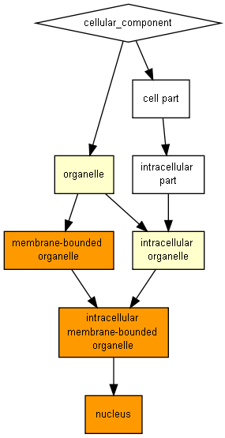
GO term | Description | P-value | FDR q-value | Enrichment (N, B, n, b)
GO:0005634 | nucleus | 4.7E-9 | 4.56E-6 | 1.24 (5033,1976,897,437)
GO:0043231 | intracellular membrane-bounded organelle | 8.67E-8 | 4.21E-5 | 1.18 (5033,2437,897,514)
GO:0043227 | membrane-bounded organelle | 9.36E-8 | 3.03E-5 | 1.18 (5033,2438,897,514)

